Help Fiori onPremise – Chamada Function Import em Batch

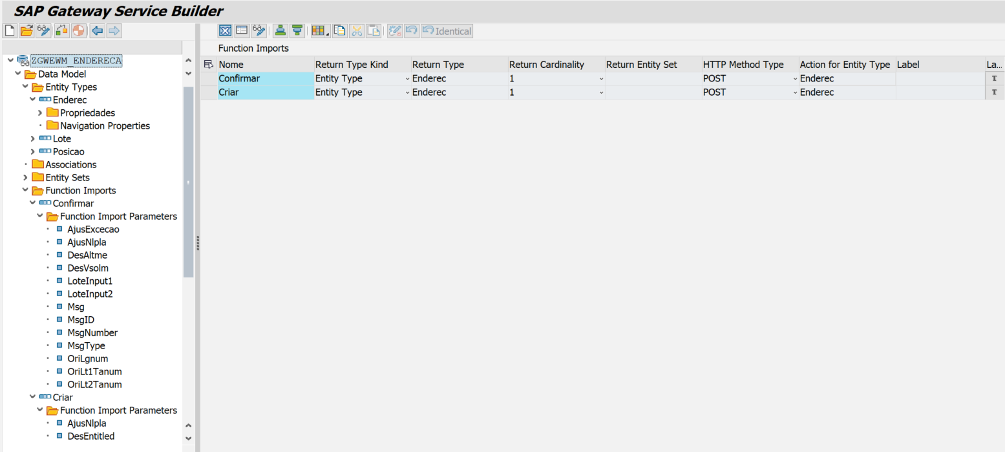

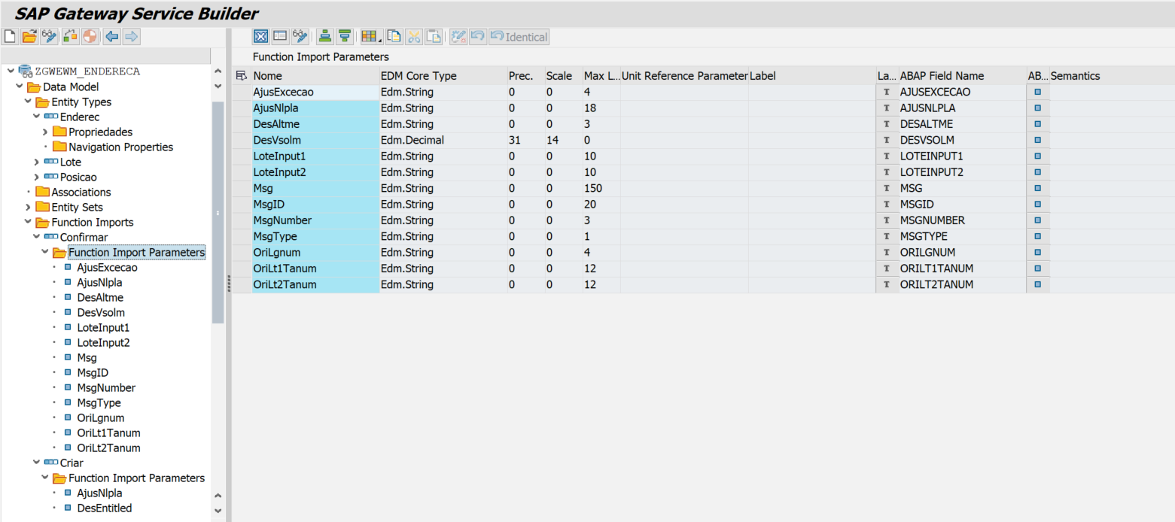

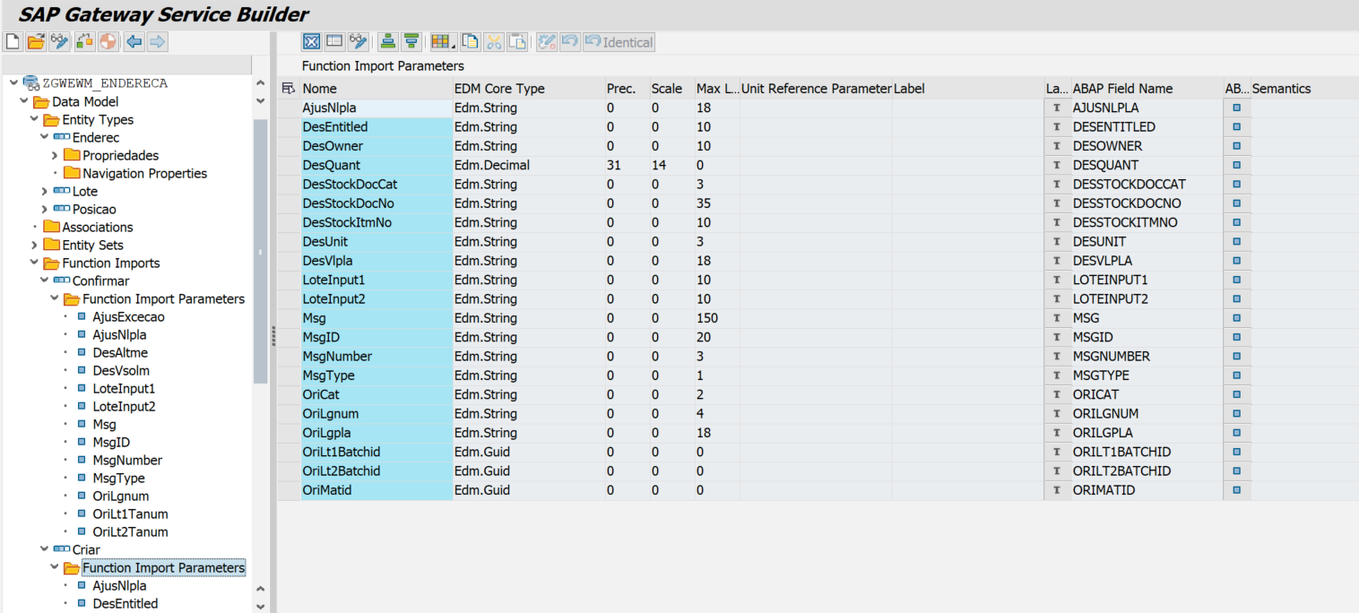

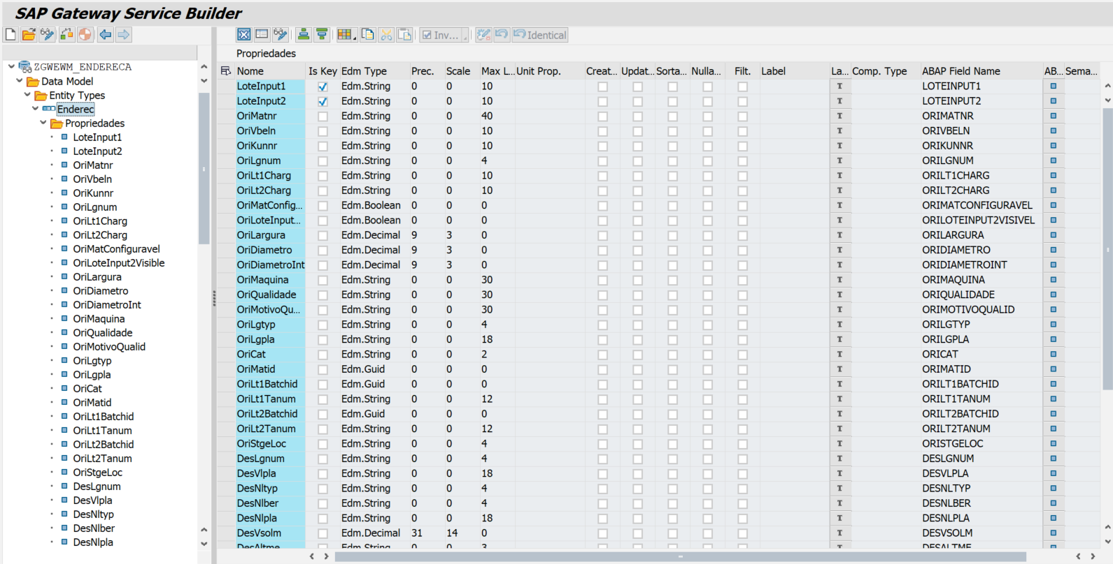

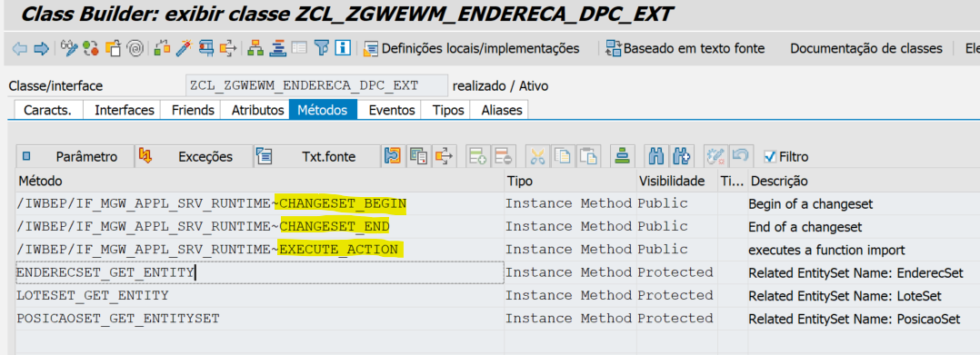
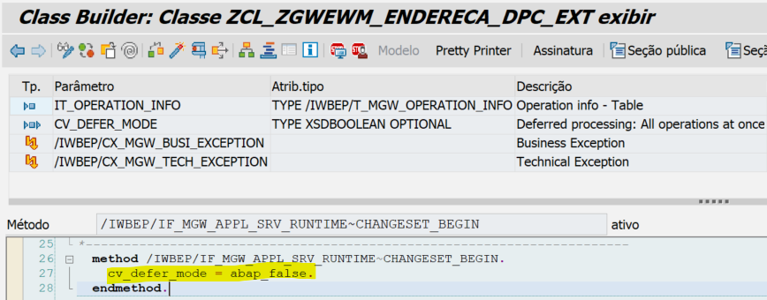
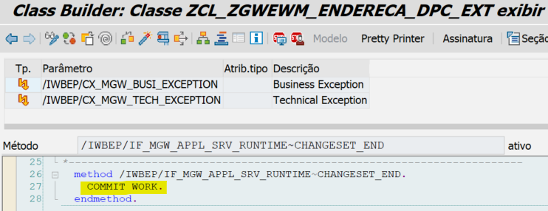

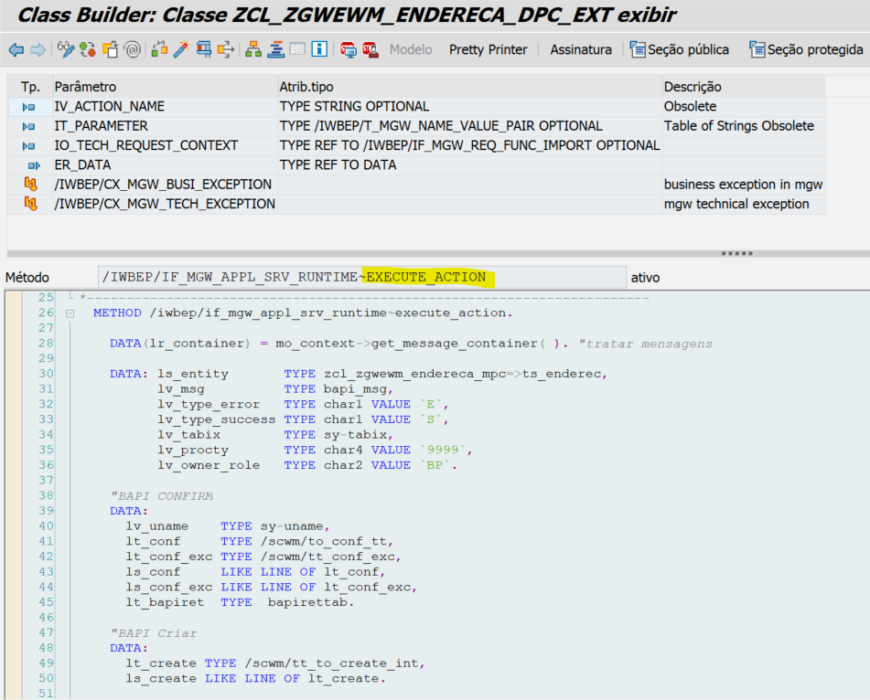

Execute_Action
METHOD /iwbep/if_mgw_appl_srv_runtime~execute_action.
DATA(lr_container) = mo_context->get_message_container( ). "tratar mensagens
DATA: ls_entity TYPE zcl_zgwewm_endereca_mpc=>ts_enderec,
lv_msg TYPE bapi_msg,
lv_type_error TYPE char1 VALUE `E`,
lv_type_success TYPE char1 VALUE `S`,
lv_tabix TYPE sy-tabix,
lv_procty TYPE char4 VALUE `9999`,
lv_owner_role TYPE char2 VALUE `BP`.
"BAPI CONFIRM
DATA:
lv_uname TYPE sy-uname,
lt_conf TYPE /scwm/to_conf_tt,
lt_conf_exc TYPE /scwm/tt_conf_exc,
ls_conf LIKE LINE OF lt_conf,
ls_conf_exc LIKE LINE OF lt_conf_exc,
lt_bapiret TYPE bapirettab.
"BAPI Criar
DATA:
lt_create TYPE /scwm/tt_to_create_int,
ls_create LIKE LINE OF lt_create.
CONSTANTS: lc_tpt TYPE /scwm/de_buscon VALUE 'TPT',
lc_02 TYPE /scwm/de_exec_step VALUE '02'.
lv_uname = sy-uname.
SELECT lgnum
FROM /scwm/user
INTO @ls_entity-Orilgnum
WHERE uname = @lv_uname
ORDER BY PRIMARY KEY.
ENDSELECT.
IF sy-subrc <> 0.
ls_entity-msgtype = lv_type_error.
ls_entity-msgid = ''.
ls_entity-msgnumber = ''.
ls_entity-msg = TEXT-003 && ` ` && lv_uname. "Erro ao buscar número do estoque para usuário.
lr_container->add_message_text_only(
iv_msg_type = lv_type_error
iv_msg_text = lv_msg
iv_is_leading_message = abap_true
iv_add_to_response_header = abap_true ).
ENDIF.
CASE iv_action_name.
"--------------------------------------------------------------
" AÇÃO Confirmar
"--------------------------------------------------------------
WHEN 'Confirmar'.
io_tech_request_context->get_converted_parameters(
IMPORTING
es_parameter_values = ls_entity ).
"P/ LOTE1 do App
IF ls_entity-orilt1tanum <> ''.
ls_conf-tanum = ls_entity-orilt1tanum.
ls_conf-nista = ls_entity-desvsolm.
ls_conf-altme = ls_entity-desaltme.
ls_conf-nlpla = ls_entity-ajusnlpla.
INSERT ls_conf INTO TABLE lt_conf.
IF ls_entity-ajusexcecao IS NOT INITIAL.
ls_conf_exc-tanum = ls_entity-orilt1tanum.
ls_conf_exc-exccode = ls_entity-ajusexcecao.
ls_conf_exc-buscon = lc_tpt.
ls_conf_exc-exec_step = lc_02.
INSERT ls_conf_exc INTO TABLE lt_conf_exc.
ENDIF.
"P/ LOTE2 do App
ELSEIF ls_entity-orilt2tanum <> ''.
ls_conf-tanum = ls_entity-orilt2tanum.
ls_conf-nista = ls_entity-desvsolm.
ls_conf-altme = ls_entity-desaltme.
ls_conf-nlpla = ls_entity-ajusnlpla.
INSERT ls_conf INTO TABLE lt_conf.
IF ls_entity-ajusexcecao IS NOT INITIAL.
ls_conf_exc-tanum = ls_entity-orilt2tanum.
ls_conf_exc-exccode = ls_entity-ajusexcecao.
ls_conf_exc-buscon = lc_tpt.
ls_conf_exc-exec_step = lc_02.
INSERT ls_conf_exc INTO TABLE lt_conf_exc.
ENDIF.
ENDIF.
CALL FUNCTION '/SCWM/TO_CONFIRM'
EXPORTING
iv_lgnum = ls_entity-orilgnum
iv_qname = lv_uname
iv_update_task = abap_true
iv_commit_work = abap_false
it_conf = lt_conf
it_conf_exc = lt_conf_exc
IMPORTING
et_bapiret = lt_bapiret.
"Teste
* lt_bapiret = VALUE bapirettab(
* ( type = 'S' message = `lote ` && ls_conf-tanum )
* ).
"Retornar mensagem
SORT lt_bapiret BY type.
READ TABLE lt_bapiret INTO DATA(ls_bapiret) WITH KEY type = lv_type_error.
IF sy-subrc = 0.
lv_tabix = sy-tabix.
"ERRO
LOOP AT lt_bapiret INTO ls_bapiret FROM lv_tabix.
ls_entity-msgtype = ls_bapiret-type.
ls_entity-msgid = ls_bapiret-id.
ls_entity-msgnumber = ls_bapiret-number.
ls_entity-msg = ls_bapiret-message.
"MSG Erro p/ o frontend
IF ls_entity-LoteInput1 IS NOT INITIAL.
lv_msg = ls_entity-LoteInput1 && `-` && ls_bapiret-message.
ELSE.
lv_msg = ls_entity-LoteInput2 && `-` && ls_bapiret-message.
ENDIF.
lr_container->add_message_text_only(
iv_msg_type = lv_type_error
iv_msg_text = lv_msg
iv_is_leading_message = abap_true
iv_add_to_response_header = abap_true ).
ENDLOOP.
IF lr_container IS NOT INITIAL.
RAISE EXCEPTION TYPE /iwbep/cx_mgw_busi_exception
EXPORTING
message_container = lr_container.
ENDIF.
ELSE.
SORT lt_bapiret BY type.
READ TABLE lt_bapiret INTO ls_bapiret WITH KEY type = lv_type_success.
IF sy-subrc = 0.
lv_tabix = sy-tabix.
"SUCESSO
LOOP AT lt_bapiret INTO ls_bapiret FROM lv_tabix.
ls_entity-msgtype = ls_bapiret-type.
ls_entity-msgid = ls_bapiret-id.
ls_entity-msgnumber = ls_bapiret-number.
ls_entity-msg = ls_bapiret-message.
"MSG Sucesso p/ frontend
IF ls_entity-LoteInput1 IS NOT INITIAL.
lv_msg = ls_entity-LoteInput1 && `-` && ls_bapiret-message.
ELSE.
lv_msg = ls_entity-LoteInput2 && `-` && ls_bapiret-message.
ENDIF.
lr_container->add_message_text_only(
iv_msg_type = lv_type_success
iv_msg_text = lv_msg
iv_is_leading_message = abap_true
iv_add_to_response_header = abap_true ).
ENDLOOP.
ENDIF.
ENDIF.
"RETORNAR resultado p/ o Frontend
copy_data_to_ref(
EXPORTING
is_data = ls_entity
CHANGING
cr_data = er_data ).
"--------------------------------------------------------------
" AÇÃO Criar
"--------------------------------------------------------------
WHEN 'Criar'.
io_tech_request_context->get_converted_parameters(
IMPORTING
es_parameter_values = ls_entity ).
IF ls_entity-orilt1batchid IS NOT INITIAL.
MOVE:
lv_procty TO ls_create-procty,
ls_entity-orimatid TO ls_create-matid,
"ls_entity-oricharg TO ls_create-charg,
ls_entity-orilt1batchid TO ls_create-batchid,
ls_entity-desquant TO ls_create-anfme,
ls_entity-desunit TO ls_create-altme,
ls_entity-orilgpla TO ls_create-vlpla,
ls_entity-desowner TO ls_create-owner,
lv_owner_role TO ls_create-owner_role,
ls_entity-desentitled TO ls_create-entitled,
lv_owner_role TO ls_create-entitled_role,
abap_true TO ls_create-single_to,
ls_entity-oricat TO ls_create-cat,
ls_entity-desstockdoccat TO ls_create-stock_doccat,
ls_entity-desstockdocno TO ls_create-stock_docno,
ls_entity-desstockitmno TO ls_create-stock_itmno,
abap_true TO ls_create-squit,
ls_entity-ajusnlpla TO ls_create-nlpla.
INSERT ls_create INTO TABLE lt_create.
ELSEIF ls_entity-orilt2batchid IS NOT INITIAL.
MOVE:
lv_procty TO ls_create-procty,
ls_entity-orimatid TO ls_create-matid,
"ls_entity-oricharg TO ls_create-charg,
ls_entity-orilt2batchid TO ls_create-batchid,
ls_entity-desquant TO ls_create-anfme,
ls_entity-desunit TO ls_create-altme,
ls_entity-orilgpla TO ls_create-vlpla,
ls_entity-desowner TO ls_create-owner,
lv_owner_role TO ls_create-owner_role,
ls_entity-desentitled TO ls_create-entitled,
lv_owner_role TO ls_create-entitled_role,
abap_true TO ls_create-single_to,
ls_entity-oricat TO ls_create-cat,
ls_entity-desstockdoccat TO ls_create-stock_doccat,
ls_entity-desstockdocno TO ls_create-stock_docno,
ls_entity-desstockitmno TO ls_create-stock_itmno,
abap_true TO ls_create-squit,
ls_entity-ajusnlpla TO ls_create-nlpla.
INSERT ls_create INTO TABLE lt_create.
ENDIF.
CALL FUNCTION '/SCWM/TO_CREATE'
EXPORTING
iv_lgnum = ls_entity-orilgnum
iv_commit_work = abap_false
it_create = lt_create
IMPORTING
et_bapiret = lt_bapiret.
" teste
* lt_bapiret = VALUE bapirettab(
* ( type = 'E' message = `lote ` && ls_create-batchid )
* ).
"Retornar mensagem
SORT lt_bapiret BY type.
READ TABLE lt_bapiret INTO ls_bapiret WITH KEY type = lv_type_error.
IF sy-subrc = 0.
lv_tabix = sy-tabix.
"ERRO
LOOP AT lt_bapiret INTO ls_bapiret FROM lv_tabix.
ls_entity-msgtype = ls_bapiret-type.
ls_entity-msgid = ls_bapiret-id.
ls_entity-msgnumber = ls_bapiret-number.
ls_entity-msg = ls_bapiret-message.
"MSG Erro p/ o frontend
IF ls_entity-LoteInput1 IS NOT INITIAL.
lv_msg = ls_entity-LoteInput1 && `-` && ls_bapiret-message.
ELSE.
lv_msg = ls_entity-LoteInput2 && `-` && ls_bapiret-message.
ENDIF.
lr_container->add_message_text_only(
iv_msg_type = lv_type_error
iv_msg_text = lv_msg
iv_is_leading_message = abap_true
iv_add_to_response_header = abap_true ).
* EXIT.
ENDLOOP.
IF lr_container IS NOT INITIAL.
RAISE EXCEPTION TYPE /iwbep/cx_mgw_busi_exception
EXPORTING
message_container = lr_container.
ENDIF.
ELSE.
SORT lt_bapiret BY type.
READ TABLE lt_bapiret INTO ls_bapiret WITH KEY type = lv_type_success.
IF sy-subrc = 0.
lv_tabix = sy-tabix.
"SUCESSO
LOOP AT lt_bapiret INTO ls_bapiret FROM lv_tabix.
ls_entity-msgtype = ls_bapiret-type.
ls_entity-msgid = ls_bapiret-id.
ls_entity-msgnumber = ls_bapiret-number.
ls_entity-msg = ls_bapiret-message.
"MSG Sucesso p/ frontend
IF ls_entity-LoteInput1 IS NOT INITIAL.
lv_msg = ls_entity-LoteInput1 && `-` && ls_bapiret-message.
ELSE.
lv_msg = ls_entity-LoteInput2 && `-` && ls_bapiret-message.
ENDIF.
lr_container->add_message_text_only(
iv_msg_type = lv_type_success
iv_msg_text = lv_msg
iv_is_leading_message = abap_true
iv_add_to_response_header = abap_true ).
* EXIT.
ENDLOOP.
ENDIF.
ENDIF.
"RETORNAR resultado p/ o Frontend
copy_data_to_ref(
EXPORTING
is_data = ls_entity
CHANGING
cr_data = er_data ).
ENDCASE.
ENDMETHOD.

